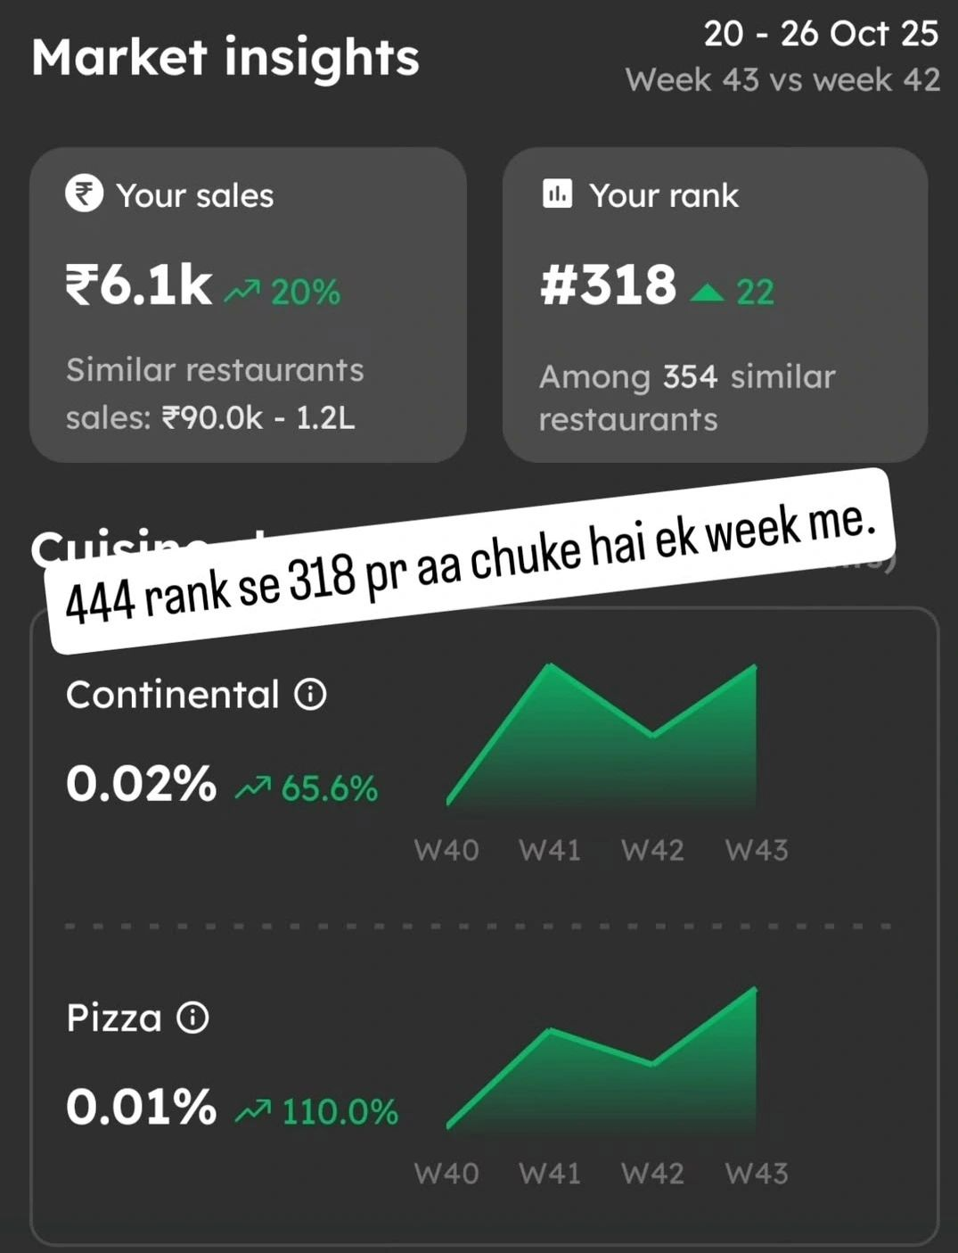
"Poore saal Zomato ko gaali denge Ki 35% comission leta hai, fir jab footfall zero rahe to Zomato hi rent nikalwata hai"

Said a friend who runs a food business in Gurugram.

The 100ft road in Indiranagar was empty.
The Breweries deserted.
The commercial hubs silent.

Symptoms of a larger emerging strategic lens for businesses.

If you're starting a new business in a tier 1 city, or an emerging tier 1.5 city, it is a factor that will influence -

1. Your business cycles
2. Your brand building
3. Your marketing campaigns
4. Your retention strategies

What is it?

Migrant populations.

On a behavioral level, migrant lives & native lives are fundamentally different.

In fact, one of the biggest reasons why a zepto or an instamart would initially take off in cities with significant migration populations & struggle in tier 2 & 3 cities.

They were not a solution for convenience, they were a solution for routines still under construction.

When one migrates to a new city, one just doesn't leave a home.
They leave everything that makes up a home.

The neighborhood shopkeepers that you keep a tab with, the roles of houses neatly divided amongst members, questions like "what is to be cooked today" not bothering you, because planning itself is long term.

When one becomes a migrant - all of those have to be rebuilt, replaced, and sought alternatives for.

That is also why, these cities see fastest adoption for all sorts of things-

It is not just you building in the dark, hoping the next iteration clicks.

It is also the consumer at times adopting in the dark, hoping something helps.

From diapers to meals.
From community to self image.

Currently, this "working out" is left to chance, We see the metro city population behaviour as a monolith.

While most businesses make profits during the festive season, businesses that make a stable revenue rest of the year, feel the pinch.

These are businesses whose majority consumer base are migrants.

Migrants, who went back home.
Whose spending will be back home.

If you don't plan for it, the best part of the year may feel like a horror show.

Your campaigns will fall flat.

And if something works out > and makes you change strategy thinking that's the right way > You may just have ended up solving for the domicile population, breaking things in the larger run.

I'm seeing this play out fantastically in the offline jewelry segment, where heavier more precious pieces find place in local rooted consumers, while migrants then sustain the minimalist section for most of the year.

Businesses need to crack the balance between strategy for migrant consumers and domicile consumers, planning for the advantages of having each, or focusing on one and adapting to their behaviours.

These will be the businesses that are least shocked and thus know how to deal with their numbers.

